State Machine Specification Document
State machine diagrams specifications of KriGo vehicle rental platform are introduced in this chapter. According to the Unified Modeling Language (UML), state machine diagrams are one of the behavioral representation types that can be used to describe dynamic behavior of particular system entities throughout their life cycles. These diagrams show how an object moves through different states under impact of certain events, conditions and business processes, thus providing a complete description of the behavior of the object.
Compared to other UML diagrams such as activity and sequence diagrams that focus on the process flow and interaction among system components respectively, state machine diagrams focus on the lifecycle of a single object. They specify the list of states an object is able to have, possible events that will cause state transition, and conditions that regulate transitions. Thus, this type of modeling helps achieve consistent behavior of entities and guarantee the implementation of business rules during lifecycle periods.
In the current chapter state machine diagrams are developed for the principal entities of the KriGo vehicle rental platform such as reservations, payments, availability of vehicle, verification request from the agency, and dispute case. Each state machine diagram shows the whole life cycle of the entity starting from its creation until it reaches a terminal state. It shows the valid transitions between states thus making it possible to understand how system objects are evolving as the users interact with the system and the administrative procedures are taking place.
Each state machine specification includes the lifecycle analysis explaining the purpose of the modeled entity, the state machine diagram that describes the permitted states and transitions, and detailed documentation describing the meaning of each state, the events that cause transitions and the terminal states. All of these specifications make it possible to provide an accurate behavioral model of the main entities of the system.
The main role of state machine diagrams is in the support of the business rules implementation, achieving consistent behavior of system modules and helping the developers to manage complicated object behaviors. Moreover, the diagrams allow performing the software testing by identifying the valid state transitions and exceptional situations that need to be validated during testing. Combining state machine diagrams with the use case, sequence and activity diagrams described in the previous chapters makes it possible to get a full behavioral specification of the KriGo vehicle rental platform.

Reservation Lifecycle Analytics
The Reservation entity is another object in the KriGo vehicle rental application. A reservation passes through certain states throughout its life-cycle starting from the time it was made by a client to its completion or cancellation. The reservation state describes the current state of affairs with the reservation, determining what operations can be performed in the system by clients, rental companies and other participants.
The reservation life-cycle starts when the client chooses a vehicle and makes a reservation. At this stage the reservation becomes pending as the system checks whether the vehicle is available and whether the payment for the rental has been received.
Once the payment has been successfully processed by the Edahabia Payment Service the reservation acquires the state of being Confirmed. This state means that the car has been successfully reserved and is to be picked up at the agreed date.
The pickup date, after the customer's identity verification and delivery of the vehicle from the rental company, marks the point where the reservation acquires the Active state meaning that at this moment the client is using the rented vehicle.
After the vehicle is returned to the rental company the reservation gets into the Inspection state. During the inspection the returned vehicle is checked for damages, excessive mileage or other violations of contract terms. If there are no damages found the reservation changes the state to Completed which signifies the end of the rental process.
In case damages or other disputes arise in the course of the inspection the reservation goes to the Disputed state. Once the dispute has been resolved the reservation becomes Completed.
Also there is the possibility of reservation cancellation before the car pickup. This operation can be done both by the client and the rental company under certain circumstances, moving the reservation from the Pending/Confirmed states to the state of Cancellation.
Thus, the described reservation life-cycle guarantees the traceability and control of every reservation, providing data consistency within the system.

Reservation State Machine
Purpose
The Reservation State Machine Diagram describes the various states that a reservation goes through during the period of its lifecycle in the KriGo system. While activity diagrams capture process flows, the state machine diagram captures the change of state in one reservation object based on certain triggers. The diagram captures the states that a reservation can take, as well as transitions between these states.
Reservation States
The reservation lifecycle consists of the following states:
- Pending: The reservation has been created and is awaiting payment confirmation or further processing.
- Confirmed: The reservation has been successfully paid for and confirmed by the system.
- Active: The customer has collected the vehicle, and the rental period is in progress.
- Inspection: The vehicle has been returned and is being inspected by the rental agency.
- Disputed: An issue, such as vehicle damage or a contractual disagreement, has been identified and requires administrative resolution.
- Completed: The reservation has been finalized successfully, and all rental activities have concluded.
- Cancelled: The reservation has been canceled before the rental begins.
State Transitions
The reservation begins in the Pending state immediately after the customer submits a booking request. Once the payment is successfully authorized, the reservation transitions to the Confirmed state. If the reservation is canceled before payment or before the pickup date, it enters the Cancelled state and the lifecycle ends.
When the customer collects the reserved vehicle, the reservation transitions from Confirmed to Active, indicating that the rental period has started. After the vehicle is returned, the reservation enters the Inspection state, where the rental agency evaluates the vehicle's condition.
If the inspection reveals no problems, the reservation transitions directly to the Completed state. However, if damage or another issue is detected, the reservation moves to the Disputed state. Once the dispute has been resolved, the reservation transitions to Completed, concluding its lifecycle.
Terminal States
The Reservation State Machine Diagram contains two terminal states:
- Completed, representing a successfully finished reservation.
- Cancelled, representing a reservation that was terminated before the rental period began.
These terminal states indicate that no further state transitions are possible for the reservation.

Conclusion
The Reservation State Machine Diagram offers a detailed view of the lifecycle of a reservation on the KriGo platform. This diagram demonstrates how the reservation processes transform through different phases, from creating to paying for it, picking up the vehicle, renting it, inspecting it, resolving disputes and completing the process. The state machine diagram offers an important framework for maintaining consistent management of reservations, enforcing rules, and implementing systems.
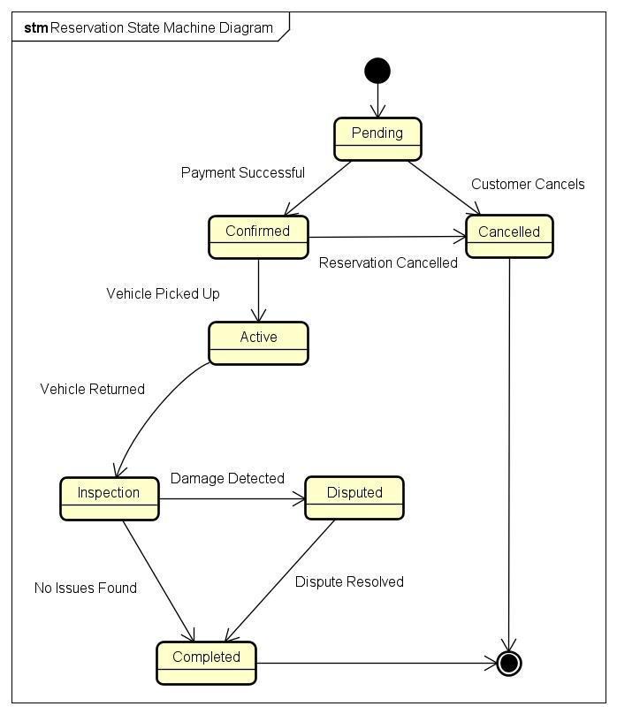
Figure 1 - Reservation State Machine Diagram

Payment Lifecycle Analysis
Payment Entity is responsible for the financial transaction related to the reservation in KriGo software. The lifecycle of this entity starts at the moment when customer wants to make a payment for the reservation and ends with the successful completion, cancellation, or refunding of the payment transaction.
In the course of its life cycle, the payment goes through several clearly defined states that guarantee secure financial transaction processing and accurate record keeping.
The payment lifecycle starts when customer makes a payment for a reservation using the services of external Edahabia payment gateway. In this case, the payment gets the Pending state while the system verifies the payment data and sends transaction request to the payment gateway.
If the transaction authorization is successfully performed by the payment gateway, the payment moves to the Authorized state which means that the payment was authorized but not completed inside the system. In this case, the system registers the transaction and changes the status of the corresponding reservation, moving the payment to the Completed state.
If the transaction authorization is refused because of the lack of money on the account, invalid card number, or some other problem, the payment moves to the Failed state. Customer can repeat the operation making another payment.
Sometimes, due to the cancellation of the reservation or approved dispute, the payment that was completed previously can move to the Refunded state.
Or, in case when customer leaves the payment procedure without completing the authorization or intentionally cancels the transaction, the payment gets the Cancelled state, ending its life cycle without changing any records about reservation payments.
This payment lifecycle guarantees the consistent state of every transaction and accurate transaction and reservation management together with secure connection with external payment service.

Payment State Machine
Purpose
The Payment State Machine Diagram shows the life cycle of a payment transaction in the KriGo system. The state machine describes various states that a payment goes through, depending on whether the payment is successfully made, cancelled, fails, or is refunded. Contrary to workflow diagrams, the state machine is purely concerned with the behavior of the Payment object based on payment events.
Payment States
The payment lifecycle consists of the following states:
- Pending: The payment has been initiated and is awaiting authorization from the Edahabia payment service.
- Authorized: The payment has been successfully approved by the payment gateway and is ready to be finalized by the system.
- Completed: The transaction has been successfully recorded, and the associated reservation has been marked as paid.
- Failed: The payment authorization was unsuccessful due to invalid payment information, insufficient funds, or another processing error.
- Refunded: The completed payment has been refunded following a reservation cancellation or an approved dispute.
- Cancelled: The payment process was canceled before successful authorization.
State Transitions
The process starts with the payment in Pending status when the customer makes a payment on the online portal. The transaction request is made by the system for the Edahabia payment gateway to authorize the payment.
If the payment gets authorized, the payment process is set into the Authorized status. Upon successful recording of the transaction and updating of the reservation payment status, the payment goes to the Completed status.
On rejection of the payment by the payment gateway, the payment moves from Pending to Failed status, marking the end of the transaction process. The customer can make another payment request if he wishes.
There could be a case whereby the customer may want to cancel his payment before completing authorization process, which leads the payment to Cancelled status.
A payment may move to Refunded status from the Completed status depending on scenarios like cancellation of the reservation and successful resolution of dispute.
Terminal States
The Payment State Machine Diagram contains the following terminal states:
- Completed, representing a successfully finalized payment.
- Failed, representing an unsuccessful payment transaction.
- Refunded, representing a completed payment that has been reimbursed.
- Cancelled, representing a payment process that was terminated before authorization.
These terminal states indicate that no additional transitions occur unless a new payment transaction is initiated.
Conclusion
The Payment State Machine Diagram is a detailed depiction of the entire process cycle of payments on the KriGo platform. The diagram shows how the payment objects go through various stages such as authorization, confirmation, cancellation, failure, and refunds during their interactions with the Edahabia payments service. Through this diagram, security and proper management of payments, finances, and reservations can be achieved.
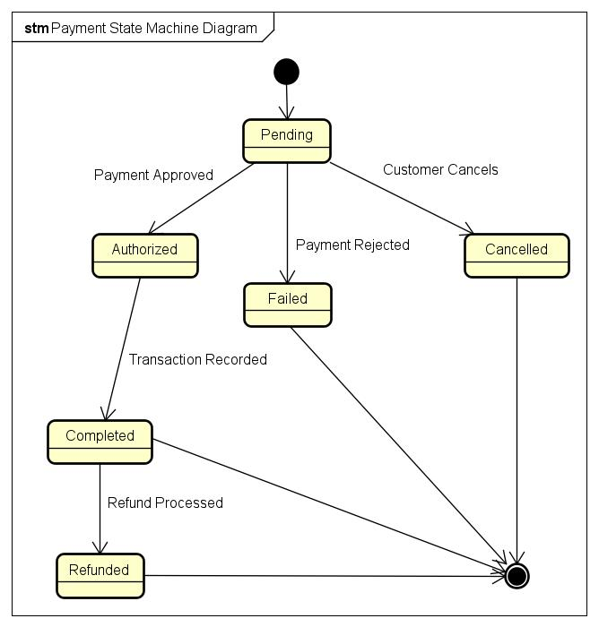
Figure 2 - Payment State Machine Diagram

Vehicle Availability Lifecycle Analysis
The Vehicle is a main resource, which is being managed using the KriGo platform. Availability of the resource will define if the resource can be rented by the customers. Throughout the whole life cycle, the vehicle will change its states depending on the reservations, rentals, maintenance, etc.
Firstly, the lifecycle of the vehicle starts after registration of the vehicle at the rental agency. After the vehicle is verified, and allowed to be used for rental, it goes into the Available state, which means that it will appear in the results of search and will be able to be reserved by the customers.
After the confirmation of the reservation made by the customer, the vehicle will go into the Reserved state. In this state, the vehicle will not be available for renting by other customers since it has already been booked for the future rent.
After the pick-up date, when the rental agency provides the vehicle to the client, the vehicle goes into the Rented state. It means that the vehicle will be rented and it will not be available for reservation and rental by other customers.
Then, when the client returns the vehicle back to the rental agency, the agency inspects the vehicle in order to check its condition. At this stage, the vehicle will enter the Inspection state. In case there were no problems found, the vehicle will return to the Available state and will be ready to make another reservation.
When maintenance is needed, either scheduled or due to some problems, the vehicle enters the Maintenance state. During this period of time, it cannot be chosen by other clients. When it completes successfully, the vehicle returns to the Available state.
In case the vehicle will not be used anymore due to sale, damage or other reasons, it enters the Inactive state. This means that the lifecycle of the vehicle in the platform ends.

Vehicle Availability State Machine
Purpose
The Vehicle Availability State Machine Diagram illustrates the journey of the life cycle of a vehicle in the KriGo framework, keeping in mind the availability of the vehicle. The diagram represents the different states through which a vehicle passes while registering, reserving, renting, inspecting, maintaining, and retiring. Thus, the availability of the vehicle can be managed effectively to avoid any reservation conflicts.
Vehicle States
The vehicle lifecycle consists of the following states:
- Available: The vehicle is ready to be rented and can appear in customer search results.
- Reserved: The vehicle has been booked by a customer for a future rental period and is temporarily unavailable for additional reservations.
- Rented: The vehicle has been collected by the customer and is currently in use.
- Inspection: The vehicle has been returned and is undergoing inspection by the rental agency.
- Maintenance: The vehicle is undergoing scheduled servicing or repairs and cannot be rented.
- Inactive: The vehicle has been permanently removed from the fleet and is no longer available for rental.
State Transitions
The lifecycle of the car begins in the Available state after the rental company makes the car available for rental. In case of a successful confirmation of the reservation, the state changes from Available to Reserved. In case of cancellation of the reservation before the pickup of the car, the state changes back to Available.
Once the customer goes on to rent the car, the state changes from Reserved to Rented, indicating that the process of renting begins. Post returning the vehicle, the car gets into the Inspection state. If there are no problems found in the car after inspection, then the state goes back to Available; else, if the car needs servicing and repair, then the state becomes Maintenance.
After the car gets serviced successfully, the state becomes Available again, making the car ready for another reservation. In case of permanent removal of the car from service, either due to retirement, selling off or being damaged beyond repair, then the state of the car changes from Available to Inactive.
Terminal State
The Vehicle Availability State Machine Diagram contains one terminal state:
- Inactive, representing a vehicle that has been permanently removed from the fleet.
This terminal state indicates that the vehicle will no longer participate in rental operations or state transitions.

Conclusion
The Vehicle Availability State Machine Diagram is a complete representation of the operational life cycle of the vehicle in the KriGo system. This diagram depicts the different ways by which vehicles can move from one state to another through availability, booking, hiring, inspection, maintenance, and disposal. In doing so, the system is able to prevent any conflicts that may arise due to incorrect management of the fleet and ensure accurate booking processes.
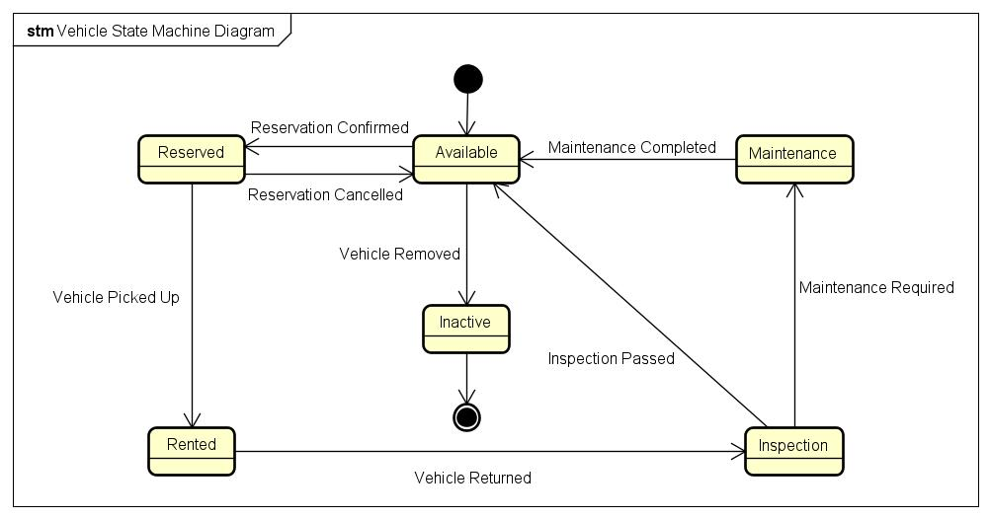
Figure 3 - Vehicle State Machine Diagram

Agency Verification Lifecycle Analysis
Agency Verification represents the process that each rental agency has to undergo in order to be able to start working within the framework of the KriGo platform. This entity's lifecycle guarantees that the rental agencies which will provide vehicle rental services within the KriGo framework will be legitimate and comply with all the regulations, ensuring platform's security and reliability.
The process starts with the rental agency submission of its registration data along with required supporting documents (business license, certificate of identity). In this case, the request enters into the state of Pending Review until the time the administrative review takes place.
The system administrator conducts a check of the provided data and verifies the correctness and validity of the documents submitted. The request for verification goes into the state of Under Review.
In case additional data needs to be provided, the verification request goes into the state of Additional Information Required and waits for uploading additional data by the agency.
As a result of the review, the request gets either verified or rejected. In the first case, the verification goes into the state of Verified and the account of the agency becomes active allowing the agency to provide vehicle rental services. In case the documents provided by the rental agency were not valid or were fraudulent in some way, the request goes to the state of Rejected and the agency gets notified about it.

Agency Verification State Machine
Purpose
The Agency Verification State Machine Diagram is the diagram illustrating the life cycle of the agency verification request for the KriGo system. It demonstrates the states that an agency verification request passes through, beginning with its submission to either being approved or rejected. Unlike the activity diagram, which shows the process of verification, the state machine diagram highlights the life of the Agency Verification object itself.
Verification States
The agency verification lifecycle consists of the following states:
- Pending Review: The agency has submitted its registration information and supporting documents, and the verification request is awaiting administrative review.
- Under Review: A system administrator is actively evaluating the submitted documents and verifying the agency's information.
- Additional Information Required: The administrator has requested additional documents or corrections before the verification process can continue.
- Verified: The agency has successfully satisfied all verification requirements, and its account is approved and activated.
- Rejected: The verification request has been denied because the submitted information does not meet the platform's verification criteria.

State Transitions
The lifecycle starts with the status of Pending Review when a verification request is made by an agency. The moment the administrator starts reviewing the request, the status changes to Under Review. In case the verification request needs to be reviewed due to the lack of some important documents, then the status changes to Additional Information Required. After the agency supplies the additional information, the status will revert back to Under Review to continue the review process. When the administrator finds out that the verification requirements have been met, the status will change to Verified. This results in the activation of the agency’s account. On the other hand, when the supplied information is not enough, not valid, fraudulently acquired, or does not comply with the policies of the platform, the verification request will move on to the Rejected status.
Terminal States
The Agency Verification State Machine Diagram contains two terminal states:
- Verified, representing a successfully approved verification request.
- Rejected, representing a verification request that has been denied.
These terminal states indicate the completion of the verification process for the current request. If a rejected agency wishes to apply again, a new verification request begins a new lifecycle.
Conclusion
The State Machine Diagram of Agency Verification represents a complete description of the life cycle of an agency verification request at KriGo. It illustrates how verification requests progress through states of being submitted, reviewed, asked for additional information, approved, or rejected. Through its defined states and state transitions, it provides a consistent and secure process of verification that ensures regulatory compliance and helps maintain the integrity of the platform by allowing it to operate only for the verified rental agencies.
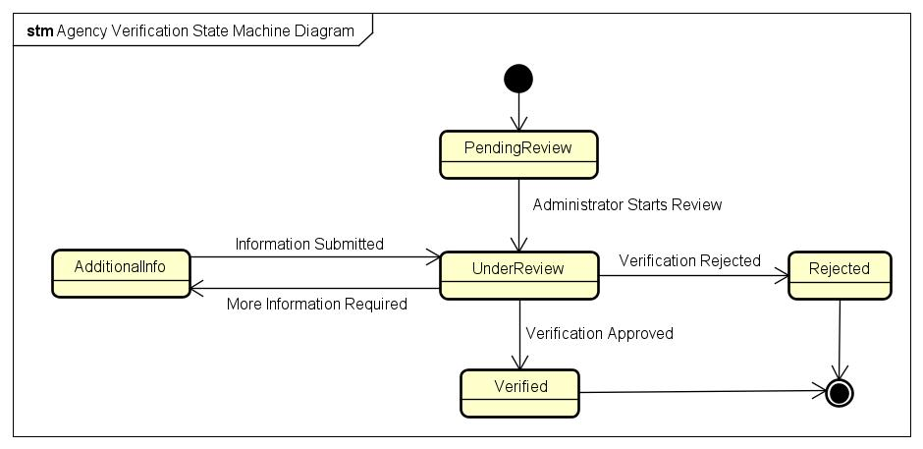
Figure 4 - Agency Verification State Machine Diagram

Disputes Lifecycle Analysis
The Dispute concept represents a problem or an issue reported by a customer or a rental agency regarding a reservation, payment, condition of a car, or other issues related to the rental. The lifecycle of such entities guarantees a consistent investigation and handling of disputes to provide fair decisions. The progress of any dispute takes place in a set of well-defined states that allow administrators to track the progress and maintain transparency for all stakeholders.
The dispute lifecycle starts when a customer or a rental agency reports a dispute on the KriGo platform. At this point, the dispute becomes Submitted, which means that the complaint has been received by the system.
Once the dispute becomes under examination of a system administrator, it changes its state to Under Investigation. This means that the administrator examines all details of the dispute, evaluates provided evidence and may contact involved parties to ask more information about the dispute.
In case there is not enough evidence to make a decision, the dispute changes its state to Awaiting Additional Information. In this situation, customers or rental agencies are asked to provide additional evidence such as documentation, photos, receipts or any other information. After this information is provided, the dispute returns back to the Under Investigation state.
After all necessary investigations, the administrator decides on how to solve the dispute. In case the complaint is valid and necessary actions have been taken (refund issued, reservation updated), the dispute changes its state to Resolved.
If the administrator finds out that the complaint is invalid or does not meet platform dispute resolution policy, the dispute becomes Rejected.
Thus, the lifecycle of a dispute provides consistent processing of all disputes on the platform.

Dispute State Machine
Purpose
The Dispute State Machine Diagram captures the entire life cycle of a dispute in KriGo. The diagram captures the distinct states that a dispute goes through as it progresses from being raised up until the dispute is either solved or rejected. Unlike the activity diagrams, which capture the process of dispute resolution, this state machine diagram captures the changes that happen to the Dispute class as a result of administration and resolutions.
Dispute States
The dispute lifecycle consists of the following states:
- Submitted: A customer or rental agency has created a dispute, and it is awaiting administrative review.
- Under Investigation: A system administrator is reviewing the dispute, examining the submitted evidence, and evaluating the facts.
- Awaiting Additional Information: Additional documentation or evidence is required before the investigation can continue.
- Resolved: The dispute has been successfully resolved, and any necessary corrective actions, such as refunds or reservation updates, have been completed.
- Rejected: The dispute has been investigated and rejected because it does not satisfy the platform's dispute resolution policies or lacks sufficient justification.
State Transitions
The life cycle of disputes begins with the creation of the Submitted stage, which occurs once the client or rental company opens a dispute on the website. Once the administrator starts reviewing the dispute, it gets transferred to the Under Investigation stage. In case the administrator feels the need for further evidence, the dispute goes to the Awaiting Additional Information stage. After the documents or evidence has been received, the dispute reverts back to the Under Investigation stage for further evaluation.
Once the investigation has been completed, there are two possible outcomes: either the administrator finds the dispute valid and that proper actions have been taken, or the dispute moves to the Resolved stage; otherwise, it gets into the Rejected stage.
Terminal States
The Dispute State Machine Diagram contains two terminal states:
- Resolved, representing a dispute that has been successfully investigated and concluded.
- Rejected, representing a dispute that has been closed without corrective action.
These terminal states indicate the completion of the dispute lifecycle. Once a dispute reaches either of these states, no further transitions occur unless a new dispute is submitted.

Conclusion
Disputes State Machine Diagram is the one that provides the complete illustration of the lifecycle of a dispute in the KriGo system. The states machine describes the process of disputes resolution in terms of stages such as disputes initiation, investigation, evidence gathering, and decision making. With the help of such a state machine, it becomes possible to ensure the structured process of dispute resolution.
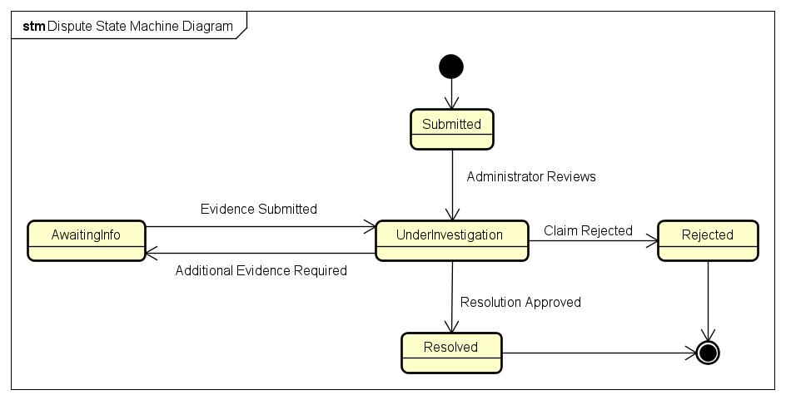
Figure 5 - Dispute State Machine Diagram

